Develop Coding: Assignment

Student Name: Mark Lawrence Lopez Domantay

For each question which includes ‘describe’ or ‘review’, write at least a paragraph worth of content to explain your answers. Include any other relevant evidence where appropriate, i.e. links or images.

Q1. Describe the purpose of using IT in creating your website and how you will use IT to plan and carry out the necessary tasks.

One purpose and advantage of using IT to form website is that it fits all the necessary information into one page, and you can store more information using functions whereas if let us say, if my website is explained using a whiteboard, I would not be able to relay all the information I want because the space is limited. I planned my website using the diagrams.net app. This app allowed to create a simple version of my website, using its functions like the “General”, “Misc”, “Advanced” and “basic” I used so I was able to create a visual example of what I want my webpage to look like. Also, this is where I commented and describe what I made. My audience was aimed at gamers and mostly young adults. I will utilize IT to present my website so that it will attract more users, because I can design it better using IT methods like HTML and CSS.

Q2. Describe methods, skills and resources needed to complete your website - explain what IT systems and software applications you need to be successful in your website project, and how you will use them

I will be using the HTML to make the foundation of my website by adding contents and I will utilize CSS to design and make it appealing to the users. I believe good researching skills are needed to make my website to fully work. To make my website do what I want I will need to research new functions to the ones I have been taught. Resources I will use will be video format sources like YouTube to aid with my work.

Q3. Describe the legal guidelines and risks that might impact your website project - how does GDPR and copyright affect website development?

From my general knowledge securing users information is of utmost importance, not to be shared to anyone else. This is key to follow so that it will not put anyone in risk of persecution. From my research, from this website <https://www.futurelearn.com/info/courses/general-data-protection-regulation/0/steps/32404> I have learnt that GDPR of General Data Protection regulation is a European Union legal requirement set in place so that it will protect individuals regarding processing personal data. It came into force on 25th May 2018. If I decide to take users personal data, I will need to comply with the rules and regulations regarding GDPR and follow carefully.

With copyright, I found from <https://www.gov.uk/copyright> that it helps protect your work by not allowing anyone else to steal it. This applies to me because I will be creating my own website, an original piece of work. This ensures that anything I create will not be copied.

Q4. Review the ongoing use of IT tools you have used for your website and describe whether they are appropriate - what are the benefits and drawbacks of IT tools and systems used? (Are you happy with the tools you used?)

I have used diagrams.net as my IT Tool to plan out entirely what my website should look like. I found it very useful because it allowed me to create a structure, I can follow, and I can base my actual website on. I used the functions such as the shapes, textbox. This IT tool let me drag and drop different kinds of shapes into the diagram, different kinds of “advanced” “Arrows” and “Flowchart”, there are many selections which allowed me to create my plan. This tool also allowed me to have multiple pages which I needed because I have different sections on my websites which needed to be explained on a different page, and so having this IT Tool made it easier for me to do that.

Q5. Describe how you would test your website to make sure it looks as intended. Describe what kind of files you used in your website and explain why you have chosen those filetypes. How can you test your website to ensure it is accessible to people with disabilities? Describe how you can overcome potential accessibility issues with your website.

I tested my website using different apps. When I was finished, I uploaded my website link to Firefox and Google Chrome to see if everything runs the same, they were few changes to be corrected and having tested it allowed me to do so. The files I used were (html) to create the foundation of my website, then used (css) to decorate and elevate my website, I also used (jpg) to link my images to my websites. I have created one folder in which everything is located, this allows me to have easy access. My website I believe is user-friendly, this is because I utilize functions such as “alt” this allows the visually impaired to appreciate my images because the function describes what the image is supposed to be.

Q6. Describe ways to improve your productivity and efficiency throughout this project (how can you make sure you are using IT tools and systems in the most effective way?) If you could have been more productive or efficient, how would you implement this for a future project?

To improve my productively, I would take on smaller task at the time. What I did was when I worked on creating my website, I work for long periods of time, this led to burnouts and lack of energy which meant I needed to take on long breaks. If I took on smaller tasks at a time, I think it would allow me to utilize my time better and finish the project sooner. The IT Tools I used was the VSC and diagrams.net, I believed I utilized VSC to the most effective way, because whenever I would input new codes I would test right away, and this should me my work-whether good or bad. It showed me my mistakes. For example: I uploaded images on my html however this did not appear on my website, and this was due to error is writing the website names, I needed to make sure they are the correct on every single page and name itself needs to match. I would implement shorter breaks and take on smaller task on my future projects so that I may be able to utilize my energy and time most effectively.

Q7. Describe the final version of your website (what is the content and layout for each page?), assess the strengths and weaknesses and describe further improvements you can make to your website. Is the website fit for purpose? (did you achieve what you set out to do in your plan?)

My website contains 6 pages, they are all in one tab, I made sure of this so that it is user-friendly and do not have to keep flicking from tab top tab. The links to the pages is visible about, I used flexbox to that they are presented well. For the first page contains the introduction of my website, introduction of the characters for the website I created. My website was an advert for a future game. The other pages contain images and information regarding other character, the description, explaining the statistics and weaknesses of each character. My last page contains a question for my users and, a release date of the game so my users are aware. The strength I believe is that my website if very descriptive, cool designs, and different types of fonts and text size catches the eye of my users; keeps them coming back. Weakness I say I could of use more flexbox in compiling the images in my final page. I could have included a combination of all my image and made fit into one whole image. I think this will look aesthetically pleasing. I firmly believe my website fitted the purpose, my website is design and target for children and young adults, I have described the game and the characters which hooks them to wait for the release date and play. It is a short and concise advert. I applied most things in my plan such as using 6 pages to break down my content. I guess I say I need to import more images and describe maybe what “weapons” the character uses and also, I could have imported a map and design better my website which more complex colors, I can do this if I had more training and more time.

Q8. Take a screenshot of your website homepage working in two different browsers. (Make sure the GitHub Pages link is visible in the screenshot).

Using Google Chrome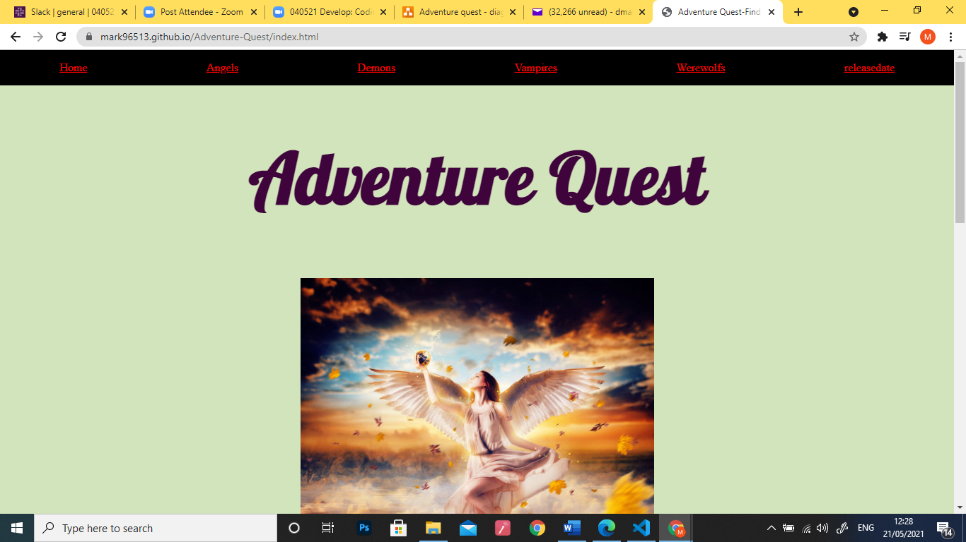

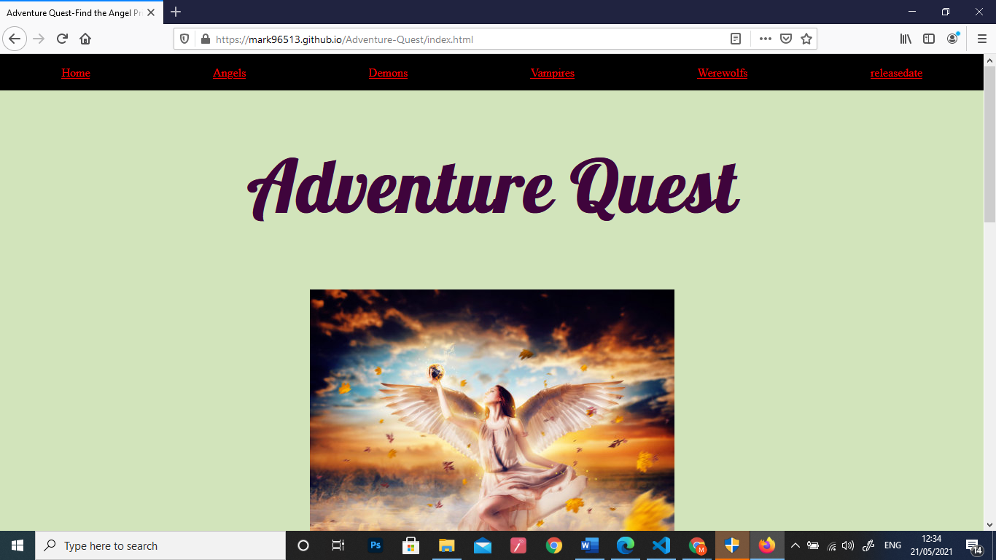Using Firefox

|  |  |  |  |  |  |  |
| --- | --- | --- | --- | --- | --- | --- |
| For Code Nation/TLM reference | | | | | | |
| 1. Develop: Coding - Assignment Mapping Document | | | | | | |
| Questions | Q1 | 1. Q2 | | 1. Q3 | | Q4 |
| TLM Criteria | 1.1.1, 1.1.3, | 1. 1.1.2, 1.1.5, 1.1.6 | | 1. 1.1.4, 1.1.7, 2.1.5 | | 1.2.1, 1.2.2, 1.3.1 |
| Questions | Q5 | Q6 | | Q7 | | Q8 |
| TLM Criteria | 1.3.4, 2.1.6, 2.1.7 | 1.3.2, 1.3.3 | | 1.2.3, 1.2.4, 1.2.5, 2.1.1, | | 2.3.1 |
|  | | | | | | |
| Website | | | | | | |
| TLM Criteria | 2.1.2, 2.1.3, 2.1.4, 2.1.8 | | 2.2.1, 2.2.2, 2.2.3, 2.2.4, 2.2.5, 2.2.6 | | 2.3.2, 2.3.3, 2.2.4 | |